WORLDGEN TEST
World 1 - configs:
WorldFieldSampler.cs
private const float ShallowStonePocketFrequencyScale = 4f;
private const float ShallowStonePocketWarpStrengthScale = 0.25f;

DirtToStoneTransitionPass.cs
private const float InversionDepthPercent = 0.35f;
private const float SurfaceQuietPercent = 0.12f;
private const float TopStoneThresholdNearSurface = 0.75f;
private const float TopStoneThresholdEndOfSurfaceQuiet = 0.85f;
private const float MidStoneThresholdStart = 0.50f;
private const float MidStoneThresholdAtInversion = 0.40f;
private const float DeepDirtThresholdAtInversion = 0.42f;
private const float DeepDirtThresholdAtBottom = 0.48f;

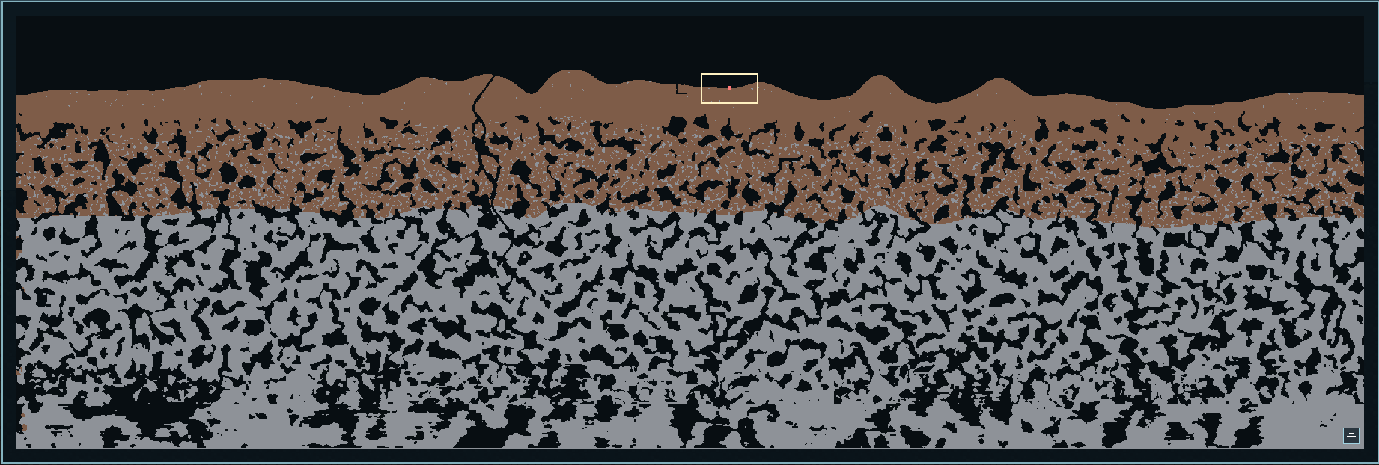
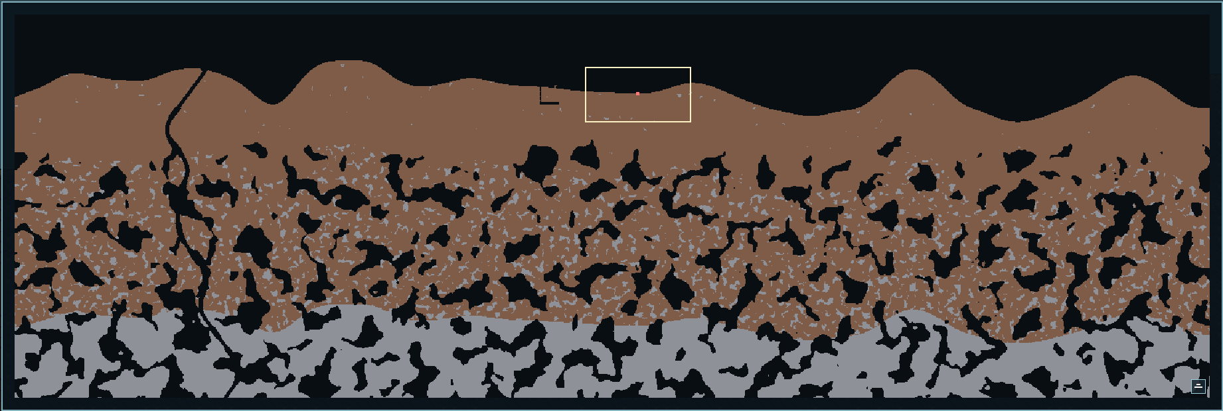

World 2 - configs:
WorldFieldSampler.cs
private const float ShallowStonePocketFrequencyScale = 4f;
private const float ShallowStonePocketWarpStrengthScale = 0.25f;

DirtToStoneTransitionPass.cs
private const float InversionDepthPercent = 0.35f;
private const float SurfaceQuietPercent = 0.12f;
private const float TopStoneThresholdNearSurface = 0.75f;
private const float TopStoneThresholdEndOfSurfaceQuiet = 0.65f;
private const float MidStoneThresholdStart = 0.50f;
private const float MidStoneThresholdAtInversion = 0.40f;
private const float DeepDirtThresholdAtInversion = 0.42f;
private const float DeepDirtThresholdAtBottom = 0.48f;

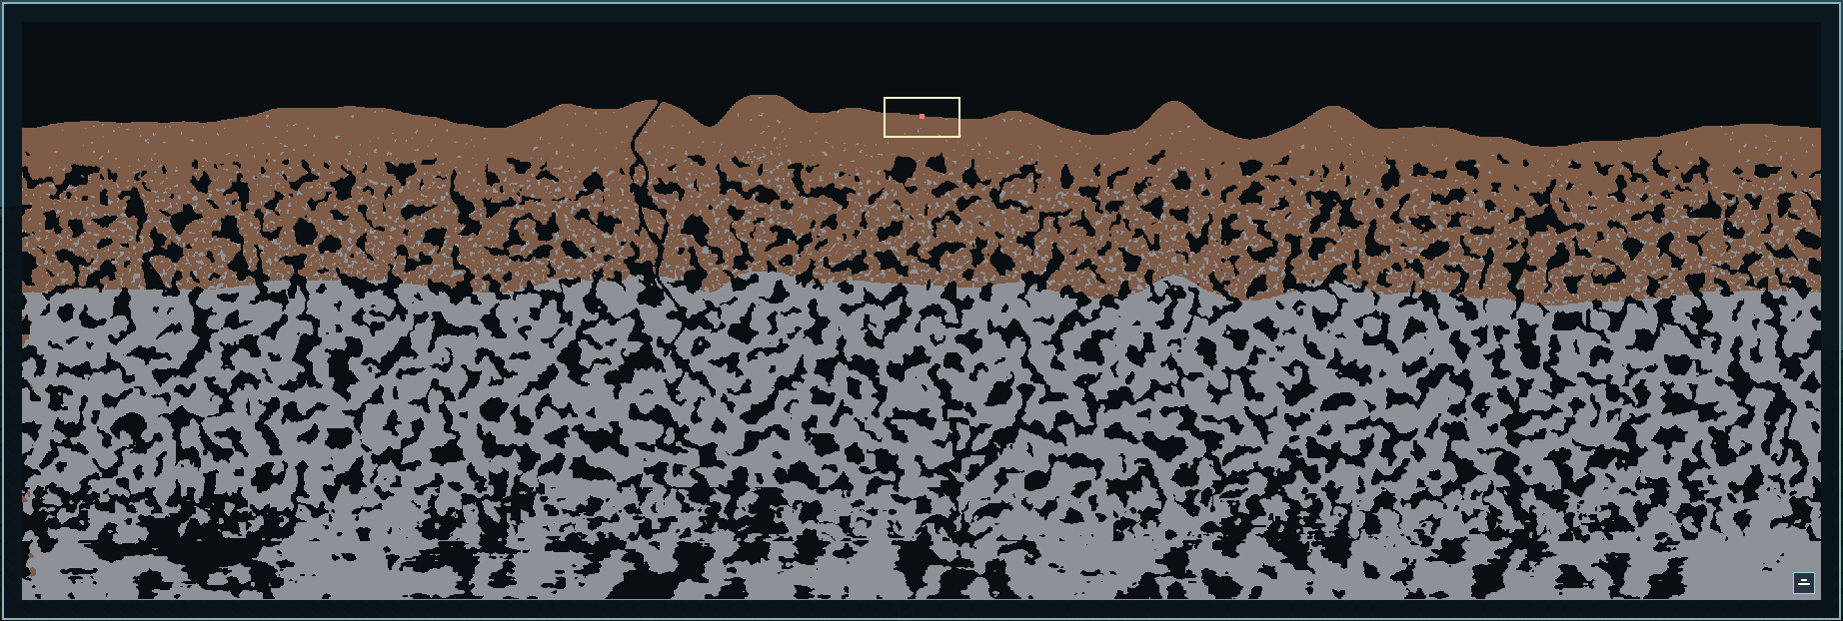
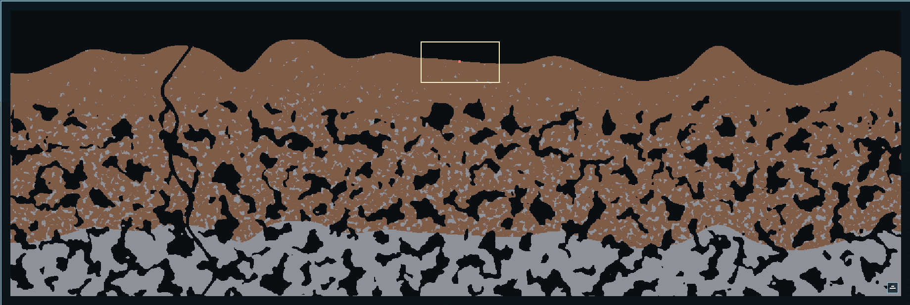

World 3 - configs:
WorldFieldSampler.cs
private const float ShallowStonePocketFrequencyScale = 3.5f;
private const float ShallowStonePocketWarpStrengthScale = 0.15f;

DirtToStoneTransitionPass.cs
private const float InversionDepthPercent = 0.35f;
private const float SurfaceQuietPercent = 0.12f;
private const float TopStoneThresholdNearSurface = 0.65f;
private const float TopStoneThresholdEndOfSurfaceQuiet = 0.75f;
private const float MidStoneThresholdStart = 0.50f;
private const float MidStoneThresholdAtInversion = 0.40f;
private const float DeepDirtThresholdAtInversion = 0.42f;
private const float DeepDirtThresholdAtBottom = 0.48f;

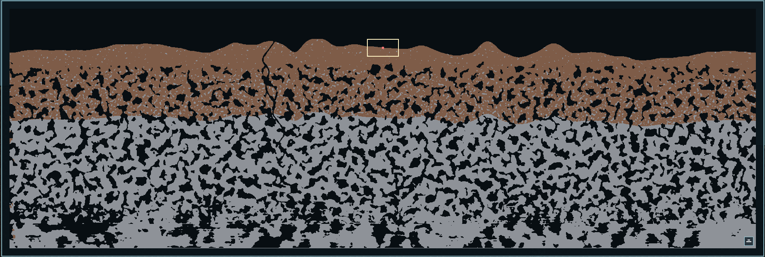
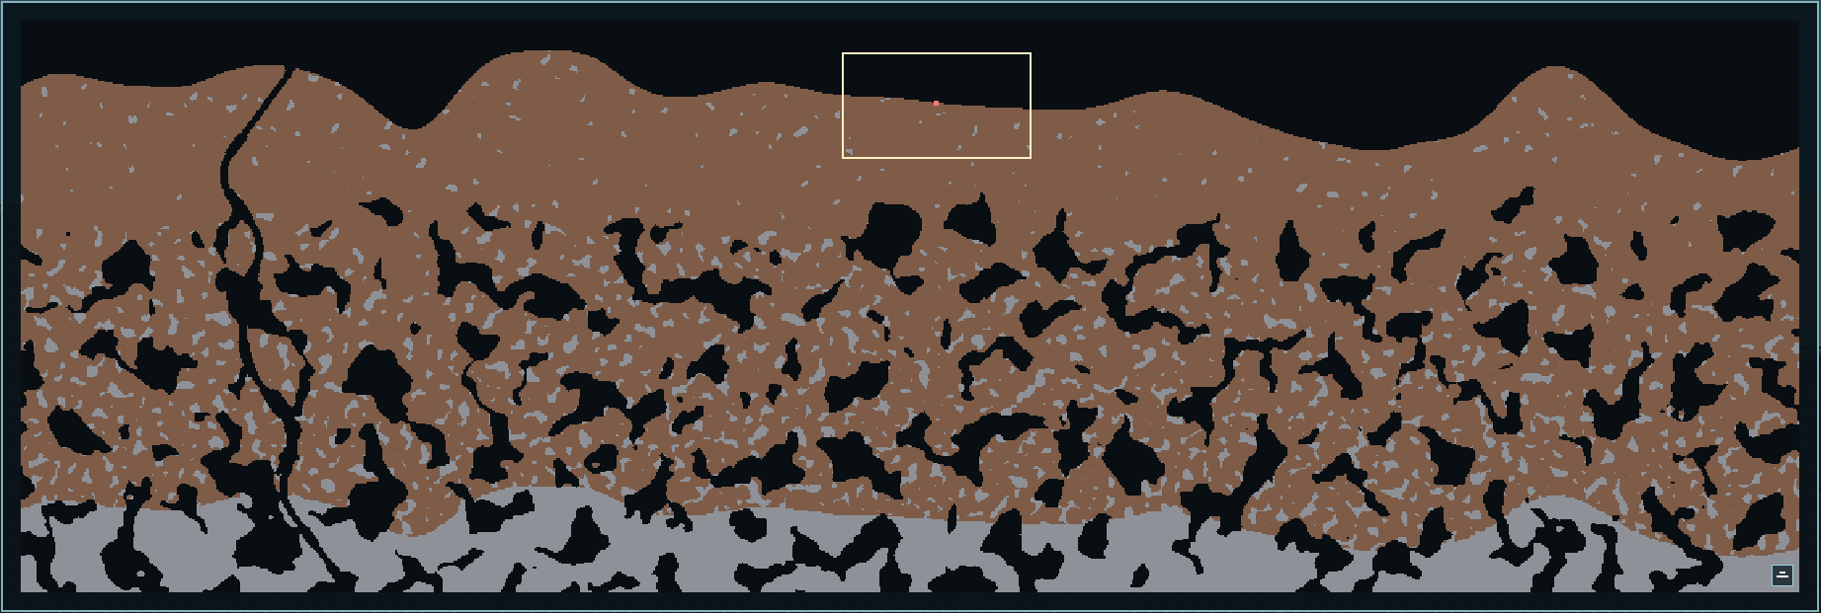

World 4 - configs:
WorldFieldSampler.cs
private const float ShallowStonePocketFrequencyScale = 3.5f;
private const float ShallowStonePocketWarpStrengthScale = 0.15f;

DirtToStoneTransitionPass.cs
private const float InversionDepthPercent = 0.35f;
private const float SurfaceQuietPercent = 0.12f;
private const float TopStoneThresholdNearSurface = 0.75f;
private const float TopStoneThresholdEndOfSurfaceQuiet = 0.75f;
private const float MidStoneThresholdStart = 0.50f;
private const float MidStoneThresholdAtInversion = 0.20f;
private const float DeepDirtThresholdAtInversion = 0.42f;
private const float DeepDirtThresholdAtBottom = 0.48f;

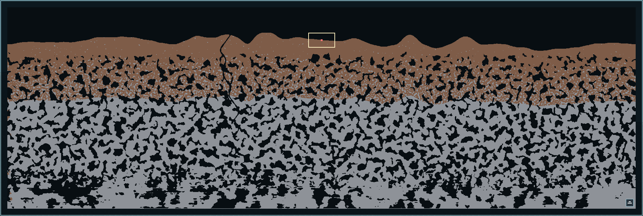
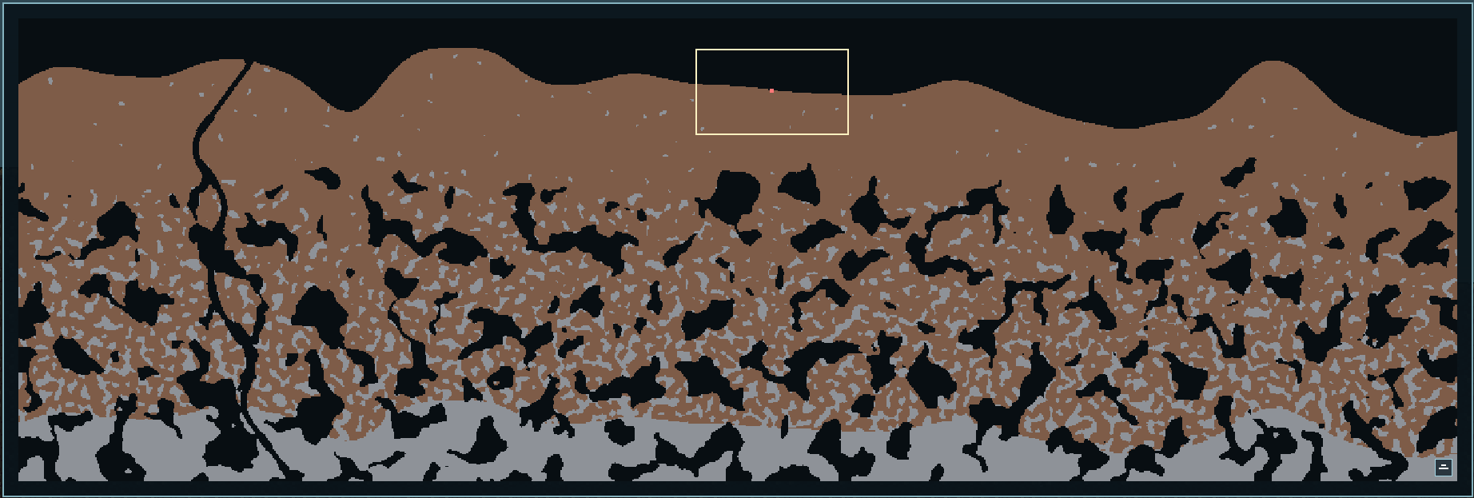

World 5 - configs:
WorldFieldSampler.cs
private const float ShallowStonePocketFrequencyScale = 3.5f;
private const float ShallowStonePocketWarpStrengthScale = 0.15f;

DirtToStoneTransitionPass.cs
private const float InversionDepthPercent = 0.35f;
private const float SurfaceQuietPercent = 0.12f;
private const float TopStoneThresholdNearSurface = 0.75f;
private const float TopStoneThresholdEndOfSurfaceQuiet = 0.55f;
private const float MidStoneThresholdStart = 0.50f;
private const float MidStoneThresholdAtInversion = 0.20f;
private const float DeepDirtThresholdAtInversion = 0.42f;
private const float DeepDirtThresholdAtBottom = 0.48f;

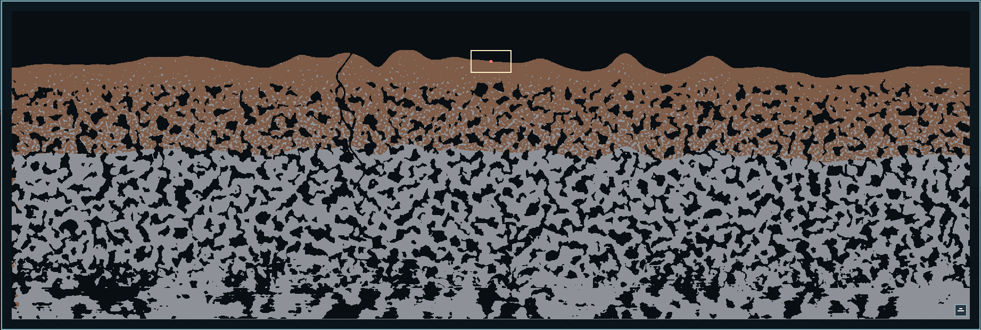
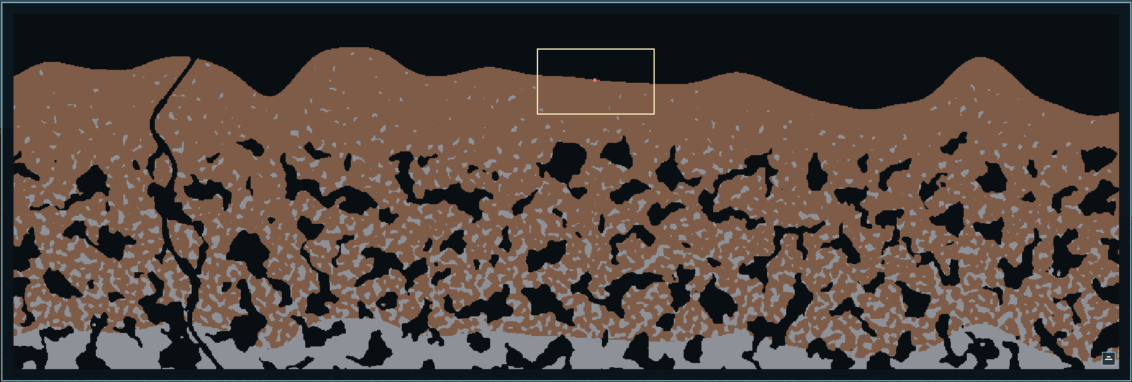

World 6 - configs:
WorldFieldSampler.cs
private const float ShallowStonePocketFrequencyScale = 3.5f;
private const float ShallowStonePocketWarpStrengthScale = 0.15f;
private const float DeepDirtPocketBaseFrequency = 0.020f;
private const float DeepDirtPocketWarpFrequency = 0.018f;
private const float DeepDirtPocketWarpStrength = 10f;

DirtToStoneTransitionPass.cs
private const float InversionDepthPercent = 0.35f;
private const float SurfaceQuietPercent = 0.12f;
private const float TopStoneThresholdNearSurface = 0.75f;
private const float TopStoneThresholdEndOfSurfaceQuiet = 0.55f;
private const float MidStoneThresholdStart = 0.50f;
private const float MidStoneThresholdAtInversion = 0.20f;
private const float DeepDirtThresholdAtInversion = 0.14f;
private const float DeepDirtThresholdAtBottom = 0.20f;

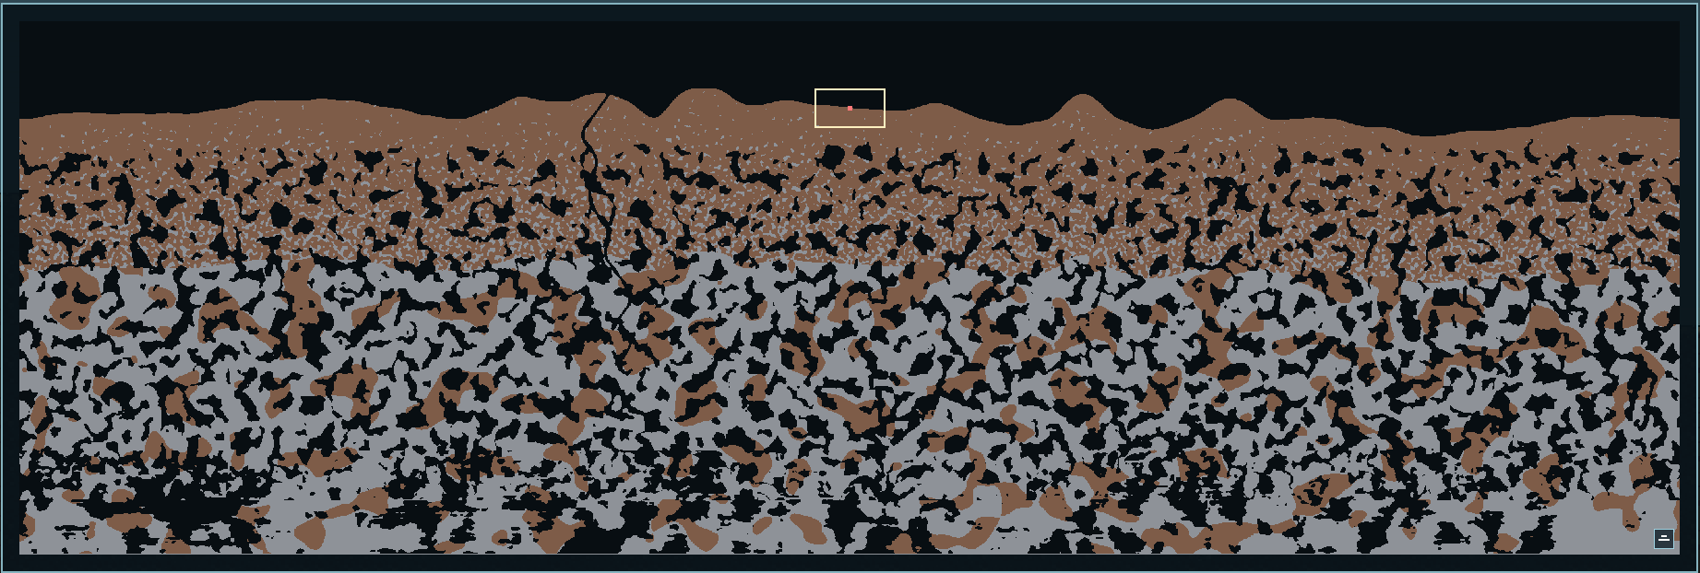
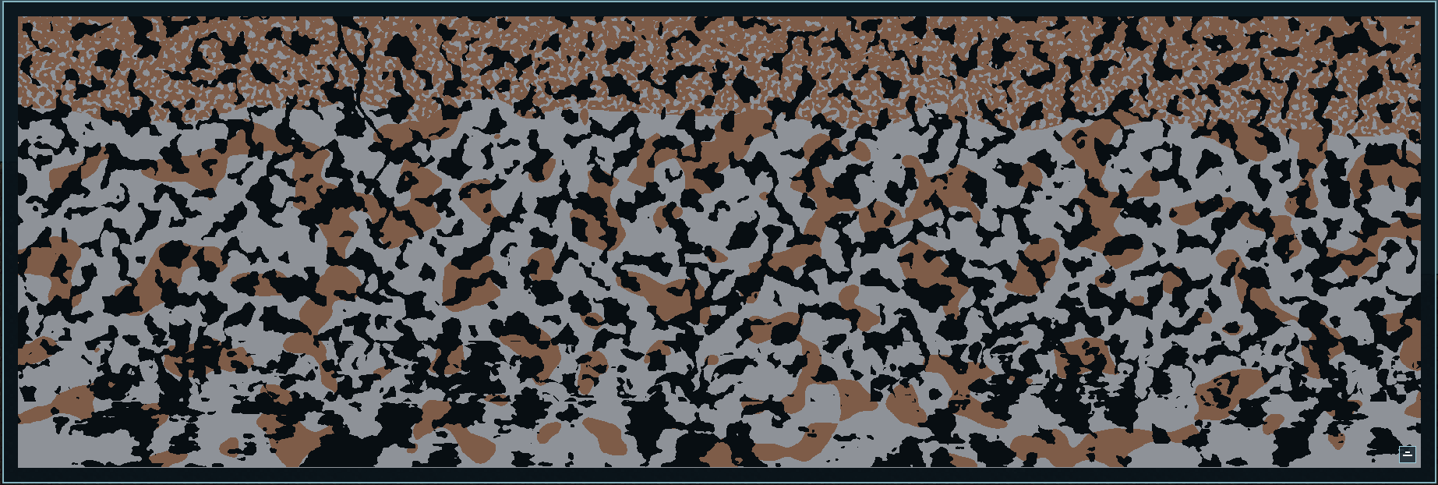

World 7 - configs:
WorldFieldSampler.cs
private const float ShallowStonePocketFrequencyScale = 3.5f;
private const float ShallowStonePocketWarpStrengthScale = 0.15f;
private const float DeepDirtPocketBaseFrequency = 3f;
private const float DeepDirtPocketWarpFrequency = 0.15f;
private const float DeepDirtPocketWarpStrength = 10f;

DirtToStoneTransitionPass.cs
private const float InversionDepthPercent = 0.35f;
private const float SurfaceQuietPercent = 0.12f;
private const float TopStoneThresholdNearSurface = 0.75f;
private const float TopStoneThresholdEndOfSurfaceQuiet = 0.55f;
private const float MidStoneThresholdStart = 0.50f;
private const float MidStoneThresholdAtInversion = 0.20f;
private const float DeepDirtThresholdAtInversion = 0.14f;
private const float DeepDirtThresholdAtBottom = 0.20f;

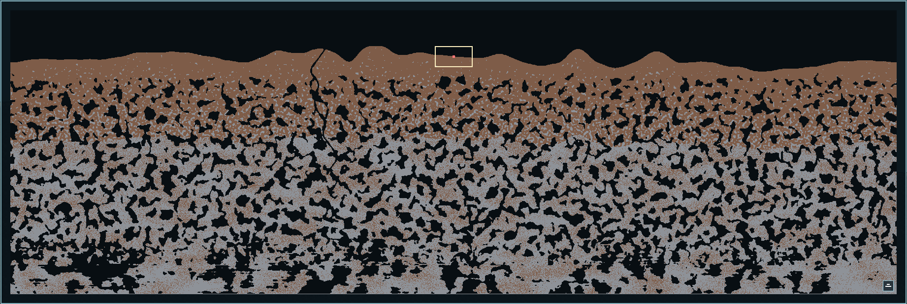

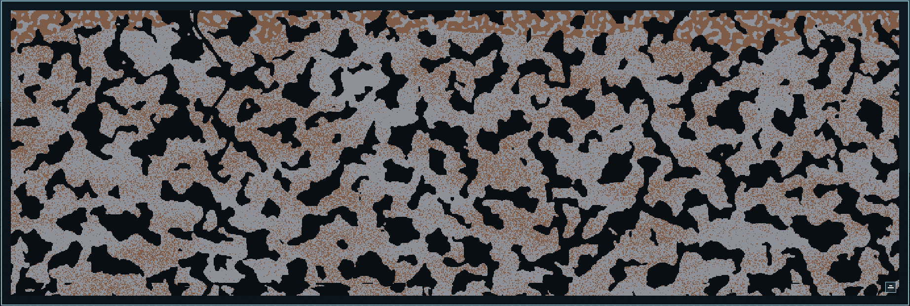

World 8 - configs:
WorldFieldSampler.cs
private const float ShallowStonePocketFrequencyScale = 3.5f;
private const float ShallowStonePocketWarpStrengthScale = 0.15f;
private const float DeepDirtPocketBaseFrequency = 2f;
private const float DeepDirtPocketWarpFrequency = 0.05f;
private const float DeepDirtPocketWarpStrength = 0.5f;

DirtToStoneTransitionPass.cs
private const float InversionDepthPercent = 0.35f;
private const float SurfaceQuietPercent = 0.12f;
private const float TopStoneThresholdNearSurface = 0.75f;
private const float TopStoneThresholdEndOfSurfaceQuiet = 0.55f;
private const float MidStoneThresholdStart = 0.50f;
private const float MidStoneThresholdAtInversion = 0.20f;
private const float DeepDirtThresholdAtInversion = 0.14f;
private const float DeepDirtThresholdAtBottom = 0.20f;

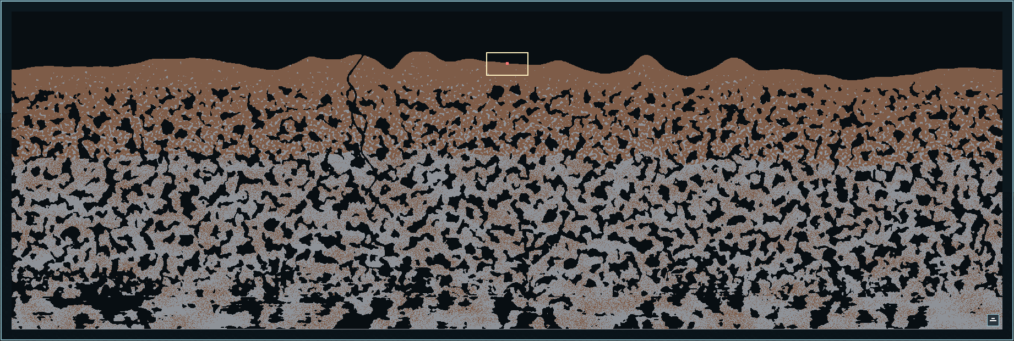
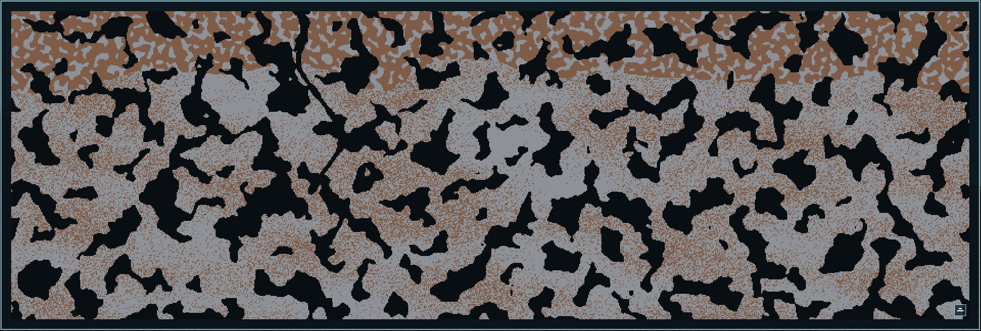

World 9 - configs:
WorldFieldSampler.cs
private const float ShallowStonePocketFrequencyScale = 3.5f;
private const float ShallowStonePocketWarpStrengthScale = 0.15f;
private const float DeepDirtPocketBaseFrequency = 1f;
private const float DeepDirtPocketWarpFrequency = 0.05f;
private const float DeepDirtPocketWarpStrength = 0.2f;

DirtToStoneTransitionPass.cs
private const float InversionDepthPercent = 0.35f;
private const float SurfaceQuietPercent = 0.12f;
private const float TopStoneThresholdNearSurface = 0.75f;
private const float TopStoneThresholdEndOfSurfaceQuiet = 0.55f;
private const float MidStoneThresholdStart = 0.50f;
private const float MidStoneThresholdAtInversion = 0.20f;
private const float DeepDirtThresholdAtInversion = 0.30f;
private const float DeepDirtThresholdAtBottom = 0.38f;

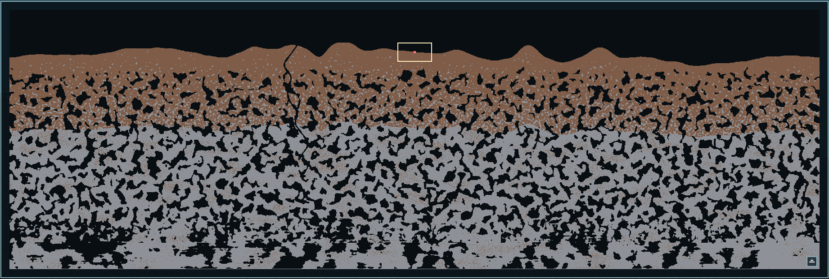
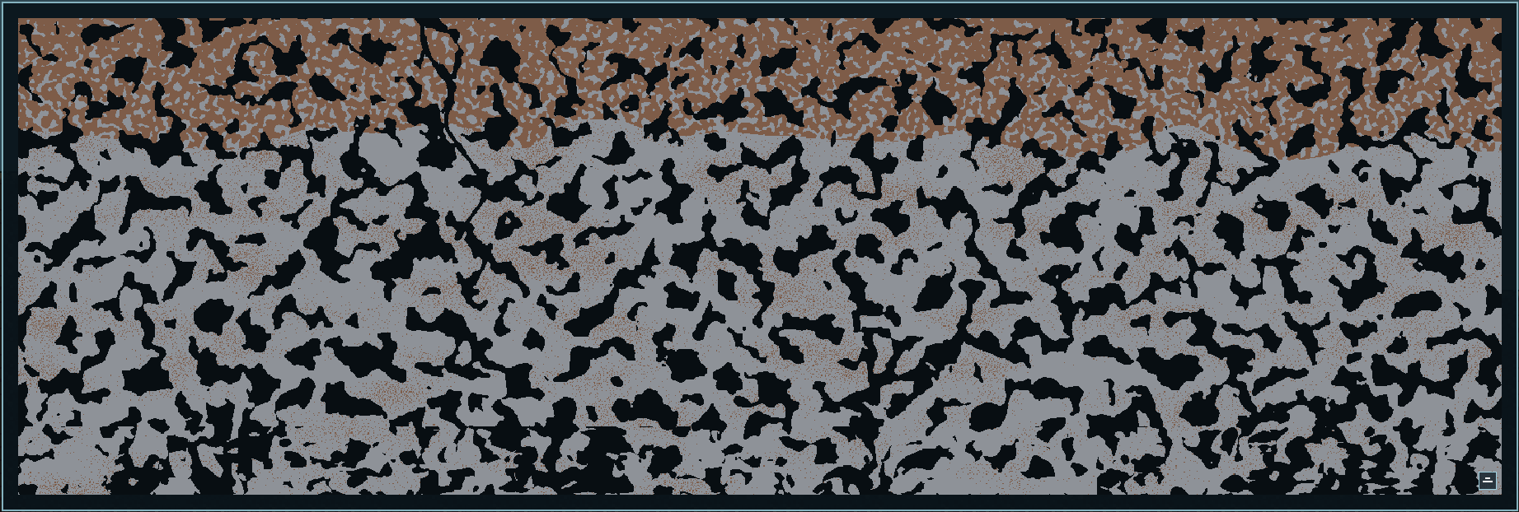

World 10 - configs:
WorldFieldSampler.cs
private const float ShallowStonePocketFrequencyScale = 3.5f;
private const float ShallowStonePocketWarpStrengthScale = 0.15f;
private const float DeepDirtPocketBaseFrequency = 0.08f;
private const float DeepDirtPocketWarpFrequency = 0.035f;
private const float DeepDirtPocketWarpStrength = 8f;

DirtToStoneTransitionPass.cs
private const float InversionDepthPercent = 0.35f;
private const float SurfaceQuietPercent = 0.12f;
private const float TopStoneThresholdNearSurface = 0.75f;
private const float TopStoneThresholdEndOfSurfaceQuiet = 0.55f;
private const float MidStoneThresholdStart = 0.50f;
private const float MidStoneThresholdAtInversion = 0.20f;
private const float DeepDirtThresholdAtInversion = 0.30f;
private const float DeepDirtThresholdAtBottom = 0.38f;

